VIT BHOPAL UNIVERSITY

School of Computer Science Engineering and Artificial Intelligence
Bhopal-Indore Highway, Kothrikalan, Sehore
Madhya Pradesh-466114
CSA1021 INTRODUCTION TO PROBLEM SOLVING AND PROGRAMMING
Project Assignment
STUDENT RECORD MANAGEMENT SYSTEM
REG.NO: 26BAI10977
NAME: TRISHEEN KAUR
BRANCH: COMPUTER SCIENCE AND ENGEERING (AI&ML)
CLASS ID: CSE1021
SEMESTER: FALL SEMESTER 2026-27
INDEX
S.No | Content | Page
1 | AIM | 4-6
2 | ALGORITHM | 7-17
3 | FLOW CHART | 18
4 | PSEUDOCODE | 19-32
5 | DESCRIPTION | 33-35
6 | DESCRIPTION OF THE PYTHON RESUME BUILDER CODE | 36-42
7 | PYTHON PROGRAM | 43-90
8 | SCREENSHOT OF OUTPUT | 91-107
9 | CONCLUSION | 108-110

AIM
The main aim of this project is to develop a simple, user-friendly, and efficient Resume Builder using Python. The project is designed to help users create a well-structured and professional resume by entering their personal, educational, and professional information into the program. A resume is an important document for students, freshers, and job seekers because it provides a summary of their qualifications, skills, projects, achievements, and other relevant information. However, creating and formatting a resume manually can sometimes be difficult and time-consuming, especially for beginners. This project aims to make the process easier by organizing the information automatically using Python.
The project aims to provide a systematic way of collecting important details such as the user's name, contact information, email address, educational qualifications, technical skills, soft skills, projects, certifications, achievements, and other relevant information. The collected information is arranged into appropriate sections so that the final resume is clear, organized, and easy to read.
Another important aim of this project is to apply basic Python programming concepts to a practical real-life application. While developing the Resume Builder, concepts such as variables, data types, user input, strings, conditional statements, functions, loops, and data formatting can be used. This helps in understanding how programming concepts can be combined to develop a useful application rather than only solving individual programming problems.
The project also aims to reduce the effort required to prepare a basic resume. Instead of repeatedly designing the structure of a resume manually, the user can provide the required information through the program, and the program can organize it into a predefined format. This makes the process faster and more convenient for users, particularly students and freshers who are creating their resumes for the first time.
Another aim is to maintain consistency in the presentation of information. A proper structure helps ensure that important details are placed under the correct headings, such as Personal Information, Education, Skills, Projects, Certifications, and Achievements. This makes the resume more readable and allows the user to present their qualifications in a systematic manner.
The project also aims to provide a foundation for developing more advanced resume-generation applications in the future. Additional features such as multiple resume templates, editing options, PDF generation, file saving, graphical user interfaces, and customized formatting can be added to improve the functionality of the application.
Overall, the aim of the Python Resume Builder is to combine basic programming knowledge with a practical application and provide a simple method for generating a structured resume while improving the user's understanding of Python programming and problem-solving.

AALGORITHM
1. Start the application
- Import the libraries needed for:
  - Creating the graphical interface
  - Reading and writing JSON files
  - Checking email and phone formats
  - Escaping text for HTML output
  - Showing file dialogs and message boxes
- Create the main Tkinter window.
- Set the application title, size, and minimum size.
- Initialize the resume data containers and status message.
- Set the visual style.
- Create the title banner, menus, form tabs, action buttons, and status bar.
- Create the fields for personal details, education, experience, projects, skills, and other resume sections.
- Initialize each repeatable section with one blank entry.
- Register the window-close action so the application can ask before exiting.
- Start the Tkinter event loop and wait for the user.
2. Process user input
- When the user types in a personal detail, update the corresponding form variable.
- When the user changes a text section, mark the form as changed.
- When the user selects Add in a repeatable section:
  - Create a new entry card.
  - Add an input field for each field in that section.
  - Add the entry to the section’s row list.
  - Renumber the visible entry cards.
  - Notify the main application that the form changed.
- When the user selects Remove Last:
  - Remove the last entry card.
  - If no entries remain, create one blank entry.
  - Renumber the remaining entries.
  - Notify the main application.
3. Collect resume data
When the user selects Preview, Save JSON, Export TXT, or Export HTML:
- Read each personal detail field and remove leading or trailing whitespace.
- Read the professional summary and other text fields.
- For each repeatable section:
  - Read every field in each row.
  - Trim whitespace from each value.
  - Include the row only if at least one field contains text.
- Store the collected information in a structured data object with these sections:
  - Personal details
  - Summary
  - Education
  - Experience
  - Projects
  - Skills
  - Certifications
  - Languages
  - Hobbies or interests
4. Validate the data
- Read and trim the email field.
- If the email field is blank, accept it.
- Otherwise, check that it has text before and after an @, and a period in the domain portion.
- If the email does not match the expected pattern:
  - Show an email warning.
  - Stop the current Preview, Save, or Export action.
- Read and trim the phone field.
- If the phone field is blank, accept it.
- Otherwise, check that it contains 7 to 20 characters drawn from digits, spaces, +, -, and parentheses.
- If the phone does not match the expected pattern:
  - Show a phone warning.
  - Stop the current action.
- If both checks pass, continue with the requested operation.
5. Preview the resume
- Collect and validate the resume data.
- If validation fails, return to the application without opening a preview.
- Build the preview text:
  - Add the person’s name in uppercase.
  - Add available contact details, separated by vertical bars.
  - Add available web links.
  - Add a separator line.
  - Add each non-empty section.
  - Add repeated education, experience, and project entries.
  - Add a footer.
- Create a separate preview window.
- Display the formatted text in a read-only text area.
- Return to the main application’s event loop.
6. Save resume data as JSON
- Collect and validate the resume data.
- If validation fails, stop the operation.
- Create a default filename from the person’s name:
  - Convert it to lowercase.
  - Replace groups of non-letter and non-digit characters with underscores.
  - Remove underscores at the beginning and end.
  - Use my_resume if the name does not produce a filename.
- Open a Save dialog with the .json extension selected.
- If the user cancels, return to the application.
- If a location is selected:
  - Open the file for writing with UTF-8 encoding.
  - Write the resume data as indented JSON.
  - Preserve non-English characters.
- If writing succeeds:
  - Update the status bar with the saved file location.
  - Show a success message.
- If a file error occurs, show an error message.
7. Load resume data from JSON
- Open a file-selection dialog for JSON files.
- If the user cancels, return to the application.
- If a file is selected:
  - Open it with UTF-8 encoding.
  - Read the file.
  - Parse its contents as JSON.
- Check that the parsed data is a dictionary/object.
- If the data is not an object, report that the file does not contain resume data.
- If the data is valid:
  - Load available personal detail values into their fields.
  - Load the summary into its text area.
  - Replace the existing education, experience, and project entries with the loaded entries.
  - Load the skills, certifications, languages, and hobbies text.
  - Use blank values or empty lists for missing sections.
- Update the status bar and show a success message.
- If reading, parsing, or validation fails, show a load error.
8. Export the resume as a text file
- Collect and validate the resume data.
- If validation fails, stop the operation.
- Create a default filename from the person’s name, ending in .txt.
- Open a Save dialog.
- If the user cancels, return to the application.
- If a location is selected:
  - Format the resume as plain text.
  - Omit optional sections that are blank.
  - For certifications, put each non-empty line in a bullet list.
  - Write the result to the selected file using UTF-8 encoding.
- If writing succeeds:
  - Update the status bar.
  - Show an export success message.
- If a file error occurs, show an export error.
9. Export the resume as an HTML file
- Collect and validate the resume data.
- If validation fails, stop the operation.
- Create a default filename from the person’s name, ending in .html.
- Open a Save dialog.
- If the user cancels, return to the application.
- If a location is selected:
  - Escape the name, contact details, headings, and resume values so that special HTML characters display safely.
  - Add the resume title, contact line, and non-empty text sections.
  - Add education, experience, and project entries when present.
  - Include the embedded CSS styling.
  - Write the HTML to the selected file using UTF-8 encoding.
- If writing succeeds:
  - Update the status bar.
  - Show a success message with instructions to open the file in a browser.
- If a file error occurs, show an export error.
10. Clear the form
- Show a confirmation dialog.
- If the user selects No, keep all resume information and return to the event loop.
- If the user selects Yes:
  - Clear each personal detail field.
  - Clear the summary and other text sections.
  - Replace the education, experience, and project entries with blank rows.
  - Set the status message to indicate the form was cleared.
11. Show information or exit
- Help: Display the application’s instructions for entering, previewing, saving, and exporting a resume.
- About: Display the application name, version, and technologies used.

Exit: Ask for confirmation. If confirmed, close the main window; otherwise, return to the event loop. 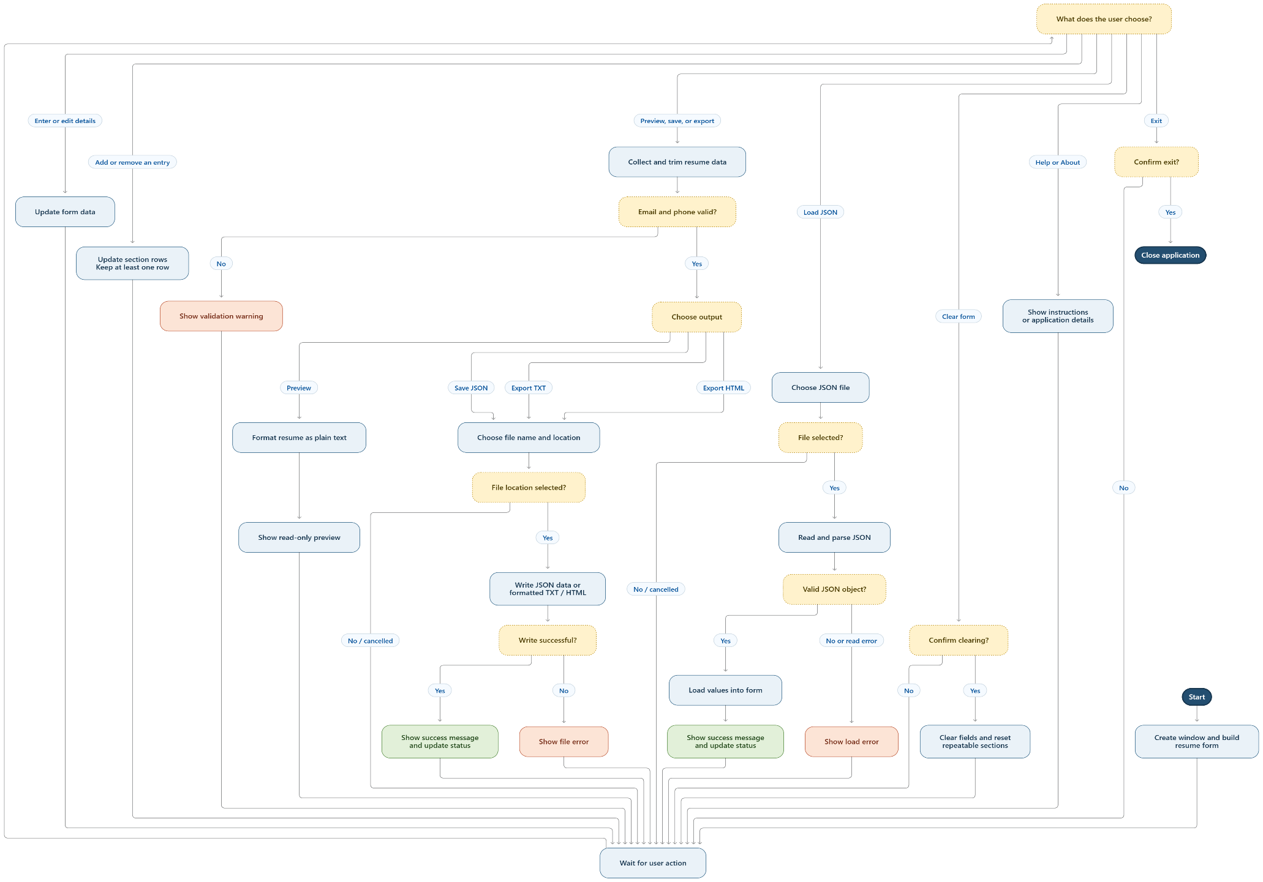 PSEUDOCODE

BEGIN PROGRAM

create main window

configure title, size, and appearance

initialize data variables and status message

create menu bar

create resume tabs and input fields

create repeatable sections for education, experience, and projects

create preview, save, and export controls

register window-close handler

start GUI event loop

WHILE window is open

WAIT for user action

IF user edits a field

store the edited value

update form status

ELSE IF user chooses Add Entry

create a new row in the chosen section

add its input fields

renumber rows

update form status

ELSE IF user chooses Remove Last Entry

remove the last row in the chosen section

IF the section has no remaining rows

create one blank row

END IF

renumber rows

update form status

ELSE IF user chooses Preview

OR user chooses Save JSON

OR user chooses Export TXT

OR user chooses Export HTML

create an empty resume data object

read and trim personal detail fields

read summary and optional text sections

FOR EACH row in education, experience, and projects

read and trim every value

IF at least one value in the row is non-empty

add the row to the resume data object

END IF

END FOR

IF email is non-empty AND email format is invalid

show email warning

return to event loop

END IF

IF phone is non-empty AND phone format is invalid

show phone warning

return to event loop

END IF

IF user chose Preview

format resume as plain text

open preview window

display text in read-only mode

ELSE IF user chose Save JSON

generate a safe default filename

ask user for a save location

IF user selected a location

TRY

write resume data as formatted JSON

update status

show save success

CATCH file error

show save error

END TRY

END IF

ELSE IF user chose Export TXT

generate a safe default filename

ask user for a save location

IF user selected a location

format resume as plain text

TRY

write formatted text to file

update status

show export success

CATCH file error

show export error

END TRY

END IF

ELSE IF user chose Export HTML

generate a safe default filename

ask user for a save location

IF user selected a location

escape text for HTML

format resume sections and entries as HTML

add styling

TRY

write HTML to file

update status

show export success

CATCH file error

show export error

END TRY

END IF

END IF

ELSE IF user chooses Load JSON

ask user to select a JSON file

IF user selected a file

TRY

read file

parse file contents as JSON

IF parsed data is not a dictionary/object

show load error

ELSE

load personal details into the form

load summary and optional text sections

replace repeated section rows with loaded data

update status

show load success

END IF

CATCH file, JSON, or data error

show load error

END TRY

END IF

ELSE IF user chooses Clear Form

ask user to confirm

IF user confirms

clear personal detail fields

clear summary and optional text fields

reset education, experience, and project sections

update status

END IF

ELSE IF user chooses Help

display instructions

ELSE IF user chooses About

display application name, version, and technologies

ELSE IF user chooses Exit

ask user to confirm

IF user confirms

close application window

END IF

END WHILE

END PROGRAM

DESCRIPTION
The Resume Builder is a Python-based project developed to create a simple and structured resume by collecting information from the user. The main purpose of this project is to make the process of preparing a resume easier, faster, and more organized. Instead of manually arranging different sections of a resume, the user can enter the required information into the program, and the Python code organizes the information into a proper format.

The program begins by taking basic personal details from the user, such as name, email address, phone number, and other contact information. These details are important because they provide the basic identity and contact information of the person applying for a job, internship, or other opportunity.

After collecting personal information, the program allows the user to enter their educational qualifications. This section can include details such as the name of the school or college, course or degree, year of study, and other relevant academic information. The project can also include sections for technical skills, soft skills, projects, certifications, achievements, and other important qualifications.

The information entered by the user is stored and processed using Python. The program then organizes the information under suitable headings and displays it in a clear and readable format. This makes the final resume easier to understand and ensures that important information is presented systematically.

This project uses basic Python programming concepts such as variables, strings, user input, conditional statements, functions, and formatting. These concepts are combined to create a practical application. The project therefore provides an opportunity to understand how Python programming can be used to solve a real-world problem.

One of the important features of this project is its simplicity. The program is designed in such a way that even a beginner can understand how it works. The user does not need advanced programming knowledge to provide the required information. By following the prompts given by the program, the user can enter their details step by step.

The Resume Builder can also be improved in the future by adding more features. For example, multiple resume templates can be provided so that users can select a design according to their requirements. The program can also be connected with file-handling features to save the generated resume. PDF generation, graphical user interfaces, editing options, and customized formatting can also be added to make the application more advanced.

This project demonstrates the practical use of Python for developing a useful application. It also improves understanding of problem-solving, logical thinking, user input, data organization, and program structure. The Resume Builder can be particularly useful for students and freshers who need to prepare a basic resume for internships, college activities, or future job opportunities.
DESCRIPTION OF THE PYTHON RESUME BUILDER CODE

The Resume Builder code is a Python-based program designed to create a structured resume by taking different types of information from the user. The code follows a simple step-by-step approach in which the user provides personal, academic, and professional details, and the program processes and displays these details in an organized resume format. The program is mainly based on Python's basic programming concepts, making it easy to understand and suitable for beginners.

The code starts by displaying the name or title of the application so that the user understands the purpose of the program. It then begins collecting the required information through user input. Python's "input()" function is used to receive information from the user. Each piece of information entered by the user is assigned to a variable so that it can be used later while creating the final resume.

The first part of the code generally collects personal information. This may include the user's full name, phone number, email address, location, and other basic contact details. Each value is stored separately in a variable. For example, the user's name can be stored in a variable such as "name", while the email address can be stored in a variable such as "email". Storing the information in variables allows the program to use the entered data multiple times without asking the user to enter it again.

The next section of the code handles the user's educational information. The program can ask the user to enter details such as their school or college name, course, degree, academic qualification, year of study, or other educational information. These values are collected using input statements and stored in appropriate variables. The information is later displayed under an Education section in the generated resume.

The code can also collect information about the user's skills. Skills are an important part of a resume because they provide information about the abilities and knowledge of the candidate. The program may ask the user to enter technical skills, programming languages, communication skills, teamwork skills, or other relevant abilities. The entered information is then stored and displayed under the Skills section.

Another important section handled by the code is projects. The user can enter the name or description of a project they have completed. For a student, this section can contain academic projects or programming projects. The code takes the project information through user input and places it in the appropriate part of the resume. This allows the user to present practical experience along with educational qualifications.

The program may also collect certifications, achievements, hobbies, interests, or other additional information. These sections can be included depending on the requirements of the user. Each input is stored in a variable and later combined with the other information while generating the final resume.

After collecting all the required information, the main part of the code is the resume generation section. In this section, Python's "print()" function is used to display the collected information. The program prints different headings and places the corresponding user information below each heading. For example, personal details are displayed under a Personal Information section, educational details under Education, and skills under Skills.

String formatting is used to combine fixed text with the information entered by the user. This allows the program to create a personalized resume instead of displaying the same information every time. The output changes according to the information provided by the user during program execution.

The code also uses proper formatting and spacing to make the generated resume easier to read. Headings can be separated from the information using blank lines or other formatting methods. This creates a clear structure between different sections of the resume. Proper formatting is important because a resume contains multiple types of information, and displaying everything together without organization would make it difficult to read.

If functions are used in the code, they help divide the program into smaller and more manageable parts. For example, a separate function can be used for collecting personal information, another for education, and another for displaying the final resume. Functions make the code more organized and can reduce repetition. They also make it easier to modify a particular section without changing the entire program.

The code can also use conditional statements when certain information is optional. For example, if the user does not want to provide a particular section, the program can check the entered value and decide whether that section should be displayed. This makes the program more flexible and allows the user to provide only the information they want to include.

Lists or other Python data structures can also be used when the program needs to store multiple values. For example, multiple skills or qualifications can be stored together and displayed one by one. This makes the code more suitable for handling resumes containing several entries instead of limiting the user to a single value.

The overall execution of the code follows a logical sequence. First, the program starts and displays the required instructions. Second, it collects personal information. Third, it collects educational details and other resume-related information. Fourth, the program stores the entered values. Finally, it formats and displays the collected information as a complete resume.

The code demonstrates several important Python concepts in a practical way. The use of variables allows the program to store user information. The "input()" function allows interaction between the user and the program. The "print()" function displays the final result. Strings are used to represent textual information, while string formatting helps combine different pieces of information into a properly structured output. Functions, conditional statements, loops, and lists can further improve the organization and functionality of the program.

The program is interactive because the final output depends on the information entered by the user. If different information is entered, a different resume is generated. This makes the program reusable for multiple users without changing the source code each time.

The Resume Builder code can also be extended by adding additional programming features. File handling can be implemented to save the generated resume into a file. PDF libraries can be used to generate a PDF version of the resume. A graphical user interface can be developed using Python libraries such as Tkinter so that users can enter information through forms instead of the command line. Multiple templates can also be added so that users can choose different resume layouts.

Overall, the code follows a simple input-process-output structure. The input consists of the information provided by the user, the processing involves storing and organizing that information, and the output is the formatted resume displayed by the program. This structure makes the project easy to understand and demonstrates how basic Python programming concepts can be combined to create a complete and practical application.

PYTHON PROGRAM
"""A friendly, beginner-level command-line resume builder.
This project is designed for an introductory programming course. It uses
ordinary Python features instead of external packages, so a student can read
the source, run it, and change it with a standard Python installation.
Run this file with Python 3. The program asks questions and saves a text
resume in the current folder when the user chooses the save option.
Run this file with Python 3. The program asks questions and prints a text
resume preview when requested.
"""
from datetime import date
from pathlib import Path
import random
import re

SECTION_NAMES = (
"Personal details",
"Education",
"Experience",
"Projects",
"Skills",
"Achievements",
)
SECTION_HINTS = {
"Personal details": "Name, email, phone, city, and a short summary",
"Education": "Course, institution, graduation year, and result",
"Experience": "Role, organization, dates, and what you contributed",
"Projects": "Project name, tools used, and the problem it solves",
"Skills": "Programming languages, tools, and people skills",
"Achievements": "Awards, certificates, volunteering, or milestones",
}

TEMPLATES = {
"1": "Classic",
"2": "Compact",
}

def print_rule(character="-", width=60):
print(character * width)

def print_title(title):
print()
print_rule("=")
print(title.center(60))
print_rule("=")

def pause():
input("\nPress Enter to continue... ")

def clean_text(value):
words = value.strip().split()
return " ".join(words)

def ask_non_empty(prompt, allow_skip=False):
while True:
answer = clean_text(input(prompt))
if answer:
return answer
if allow_skip:
return ""
print("Please enter something so this field is not blank.")

def ask_yes_no(prompt, default=True):
hint = "Y/n" if default else "y/N"
while True:
answer = input(f"{prompt} ({hint}): ").strip().lower()
if answer == "":
return default
if answer in ("y", "yes"):
return True
if answer in ("n", "no"):
return False
print("Please type y or n.")

def ask_menu_choice(prompt, valid_choices):
while True:
choice = input(prompt).strip()
if choice in valid_choices:
return choice
print("That choice is not in the menu. Please try again.")

def ask_integer(prompt, minimum=None, maximum=None, allow_skip=False):
while True:
raw_value = input(prompt).strip()
if allow_skip and raw_value == "":
return None
try:
number = int(raw_value)
except ValueError:
print("Please enter a whole number.")
continue
if minimum is not None and number < minimum:
print(f"Enter a number that is at least {minimum}.")
continue
if maximum is not None and number > maximum:
print(f"Enter a number no greater than {maximum}.")
continue
return number

def valid_email(email):
pattern = r"^[^\s@]+@[^\s@]+\.[^\s@]+$"
return re.match(pattern, email) is not None
parts = email.split("@")
return len(parts) == 2 and "." in parts[1] and " " not in email

def ask_email(prompt):
while True:
email = input(prompt).strip()
if email == "":
return ""
if valid_email(email):
return email
print("That email does not look right. Try name@example.com.")

def ask_phone(prompt):
while True:
phone = input(prompt).strip()
if phone == "":
return ""
digits = [character for character in phone if character.isdigit()]
allowed = all(character.isdigit() or character in "+-() ." for character in phone)
if allowed and 7 <= len(digits) <= 15:
return phone
print("Use 7 to 15 digits and only ordinary phone symbols.")

def split_items(text):
parts = text.split(",")
items = []
for part in parts:
item = clean_text(part)
if item:
items.append(item)
return items

def unique_in_order(items):
result = []
seen = set()
for item in items:
key = item.casefold()
if key not in seen:
result.append(item)
seen.add(key)
return result

def ask_list(prompt, allow_skip=True, unique=True):
while True:
raw_value = input(prompt).strip()
if raw_value == "" and allow_skip:
return []
items = split_items(raw_value)
if items:
return unique_in_order(items) if unique else items
print("Please enter at least one item, separated with commas.")

def ask_multiline_list(label, required=False):
print(f"\nAdd {label.lower()} one at a time.")
print("Leave an entry blank when you are finished.")
entries = []
while True:
entry = clean_text(input(f"{label} #{len(entries) + 1}: "))
if entry == "":
if required and not entries:
print(f"Please add at least one {label.lower()} item.")
continue
break
entries.append(entry)
return unique_in_order(entries)

def make_empty_resume():
return {
"personal": {
"name": "",
"email": "",
"phone": "",
"city": "",
"summary": "",
},
"education": [],
"experience": [],
"projects": [],
"skills": [],
"achievements": [],
"template": "Classic",
"created": date.today().isoformat(),
}

def collect_personal_details(resume):
print_title("Personal details")
personal = resume["personal"]
personal["name"] = ask_non_empty("Full name: ")
personal["email"] = ask_email("Email (optional): ")
personal["phone"] = ask_phone("Phone (optional): ")
personal["city"] = ask_non_empty("City or location (optional): ", allow_skip=True)
print("\nWrite two or three honest sentences about your interests and strengths.")
personal["summary"] = ask_non_empty("Profile summary (optional): ", allow_skip=True)
return personal

def collect_education(resume):
print_title("Education")
if not ask_yes_no("Would you like to add education details?"):
return resume["education"]
records = resume["education"]
while True:
record = {
"course": ask_non_empty("Course or qualification: "),
"institution": ask_non_empty("Institution: "),
"year": ask_non_empty("Graduation year (or expected year): "),
"result": ask_non_empty("Result or relevant note (optional): ", allow_skip=True),
}
records.append(record)
if not ask_yes_no("Add another education record?", default=False):
break
return records

def collect_experience(resume):
print_title("Experience")
print("You can include internships, part-time work, or volunteering.")
if not ask_yes_no("Would you like to add experience?"):
return resume["experience"]
records = resume["experience"]
while True:
role = ask_non_empty("Role or position: ")
organization = ask_non_empty("Organization: ")
dates = ask_non_empty("Dates (for example, Jun 2025 - Aug 2025): ")
details = ask_list("Main contributions, separated by commas: ", allow_skip=False)
records.append({
"role": role,
"organization": organization,
"dates": dates,
"details": details,
})
if not ask_yes_no("Add another experience record?", default=False):
break
return records

def collect_projects(resume):
print_title("Projects")
if not ask_yes_no("Would you like to add a project?"):
return resume["projects"]
projects = resume["projects"]
while True:
name = ask_non_empty("Project name: ")
description = ask_non_empty("What does it do? (one sentence): ")
tools = ask_list("Tools or languages used (comma-separated): ", allow_skip=True)
projects.append({"name": name, "description": description, "tools": tools})
if not ask_yes_no("Add another project?", default=False):
break
return projects

def collect_skills(resume):
print_title("Skills")
skills = ask_list("Enter skills separated by commas: ", allow_skip=False)
resume["skills"] = skills
print(f"Saved {len(skills)} distinct skill(s).")
return skills

def collect_achievements(resume):
print_title("Achievements")
resume["achievements"] = ask_multiline_list("Achievements", required=False)
return resume["achievements"]

def choose_template(resume):
print_title("Choose a layout")
for number, template_name in TEMPLATES.items():
print(f"{number}. {template_name}")
choice = ask_menu_choice("Layout number: ", TEMPLATES.keys())
resume["template"] = TEMPLATES[choice]
return resume["template"]

def bullet_lines(items, indent=" "):
lines = []
for item in items:
lines.append(f"{indent}* {item}")
return lines

def add_section(lines, heading, content_lines):
if not content_lines:
return
lines.append("")
lines.append(heading.upper())
lines.append("-" * len(heading))
lines.extend(content_lines)

def format_personal(personal, compact=False):
lines = [personal["name"].upper()]
contact = []
for key in ("email", "phone", "city"):
if personal[key]:
contact.append(personal[key])
if contact:
separator = " | " if compact else " • "
lines.append(separator.join(contact))
if personal["summary"]:
lines.extend(["", "PROFILE", personal["summary"]])
return lines

def format_education(records):
lines = []
for record in records:
title = f"{record['course']} — {record['institution']}"
lines.append(title)
lines.append(f" {record['year']}")
if record["result"]:
lines.append(f" {record['result']}")
return lines

def format_experience(records):
lines = []
for record in records:
lines.append(f"{record['role']} — {record['organization']}")
lines.append(f" {record['dates']}")
lines.extend(bullet_lines(record["details"], indent=" "))
return lines

def format_projects(projects):
lines = []
for project in projects:
lines.append(project["name"])
lines.append(f" {project['description']}")
if project["tools"]:
lines.append(" Tools: " + ", ".join(project["tools"]))
return lines

def build_resume_text(resume):
compact = resume["template"] == "Compact"
lines = format_personal(resume["personal"], compact=compact)
add_section(lines, "Education", format_education(resume["education"]))
add_section(lines, "Experience", format_experience(resume["experience"]))
add_section(lines, "Projects", format_projects(resume["projects"]))
if resume["skills"]:
add_section(lines, "Skills", [", ".join(resume["skills"])])
add_section(lines, "Achievements", bullet_lines(resume["achievements"]))
return "\n".join(lines).strip() + "\n"

def display_resume(resume):
print_title("Resume preview")
print(build_resume_text(resume))
print_rule()

def safe_filename(name):
cleaned = re.sub(r"[^A-Za-z0-9_-]+", "_", name.strip())
cleaned = cleaned.strip("_")
return cleaned or "my_resume"

def save_resume(resume):
default_name = safe_filename(resume["personal"]["name"]) + "_resume.txt"
print(f"\nSuggested file name: {default_name}")
file_name = input("File name (press Enter to use suggestion): ").strip()
if not file_name:
file_name = default_name
if not file_name.lower().endswith(".txt"):
file_name += ".txt"
try:
path = Path(file_name)
path.write_text(build_resume_text(resume), encoding="utf-8")
except OSError as error:
print(f"The file could not be saved: {error}")
return None
print(f"Resume saved to: {path.resolve()}")
return path

def count_resume_items(resume):
counts = {
"Education": len(resume["education"]),
"Experience": len(resume["experience"]),
"Projects": len(resume["projects"]),
"Skills": len(resume["skills"]),
"Achievements": len(resume["achievements"]),
}
return counts

def show_resume_stats(resume):
print_title("Resume contents")
counts = count_resume_items(resume)
for section, amount in counts.items():
print(f"{section:14} : {amount}")
print(f"{'Template':14} : {resume['template']}")

def search_resume(resume):
print_title("Search your resume")
query = clean_text(input("Word or phrase to find: "))
if not query:
print("No search phrase was entered.")
return []
matches = []
for number, line in enumerate(build_resume_text(resume).splitlines(), start=1):
if query.casefold() in line.casefold():
matches.append((number, line))
if matches:
print(f"Found {len(matches)} matching line(s):")
for number, line in matches:
print(f"{number:>3}: {line}")
else:
print("No matching text was found.")
return matches

def sort_skills(resume):
sorted_skills = sorted(resume["skills"], key=str.casefold)
print_title("Skills in alphabetical order")
if not sorted_skills:
print("There are no skills to sort yet.")
else:
for index, skill in enumerate(sorted_skills, start=1):
print(f"{index}. {skill}")
return sorted_skills

def reverse_skills(resume):
print_title("Skills in reverse entry order")
reversed_skills = resume["skills"][::-1]
if not reversed_skills:
print("There are no skills to reverse yet.")
else:
for skill in reversed_skills:
print(f"- {skill}")
return reversed_skills

def skill_overlap(resume):
print_title("Compare skills with a job")
job_skills = ask_list("Job skills, separated by commas: ", allow_skip=False)
resume_set = {skill.casefold() for skill in resume["skills"]}
job_set = {skill.casefold() for skill in job_skills}
matched = sorted(resume_set & job_set)
missing = sorted(job_set - resume_set)
print(f"Matching skills: {', '.join(matched) if matched else 'none yet'}")
print(f"Skills to consider learning: {', '.join(missing) if missing else 'none'}")
return matched, missing

def count_words(text):
words = text.split()
count = 0
for word in words:
if word:
count += 1
return count

def summary_word_count(resume):
summary = resume["personal"]["summary"]
amount = count_words(summary)
print_title("Profile summary length")
print(f"Your summary contains {amount} word(s).")
if amount == 0:
print("Add a short summary if you want an introduction at the top.")
elif amount > 60:
print("Consider trimming it so the most useful details stand out.")
else:
print("This is a readable length for a short introductory profile.")
return amount

def completeness_score(resume):
checks = [
bool(resume["personal"]["name"]),
bool(resume["personal"]["email"] or resume["personal"]["phone"]),
bool(resume["education"]),
bool(resume["skills"]),
bool(resume["projects"] or resume["experience"]),
]
completed = sum(1 for check in checks if check)
return completed, len(checks)

def show_checklist(resume):
print_title("Quick resume checklist")
checks = [
("Name is present", bool(resume["personal"]["name"])),
("At least one contact method", bool(resume["personal"]["email"] or resume["personal"]["phone"])),
("Education is included", bool(resume["education"])),
("Skills are included", bool(resume["skills"])),
("Experience or a project is included", bool(resume["experience"] or resume["projects"])),
("Summary is included", bool(resume["personal"]["summary"])),
]
for label, completed in checks:
mark = "[x]" if completed else "[ ]"
print(f"{mark} {label}")
score, total = completeness_score(resume)
print(f"\nCore sections completed: {score} of {total}")

def edit_personal_details(resume):
old_personal = resume["personal"].copy()
print("Current name:", old_personal["name"])
if ask_yes_no("Replace personal details?"):
collect_personal_details(resume)
return resume["personal"]

def edit_skills(resume):
print("Current skills:", ", ".join(resume["skills"]) or "none")
if ask_yes_no("Replace the complete skills list?"):
collect_skills(resume)
return resume["skills"]

def remove_skill(resume):
print_title("Remove a skill")
if not resume["skills"]:
print("There are no skills to remove.")
return False
for index, skill in enumerate(resume["skills"], start=1):
print(f"{index}. {skill}")
position = ask_integer("Skill number to remove: ", minimum=1, maximum=len(resume["skills"]))
removed = resume["skills"].pop(position - 1)
print(f"Removed: {removed}")
return True

def add_random_prompt():
prompts = [
"What problem did your project solve for another person?",
"Which class assignment taught you a useful technical skill?",
"When did you explain a difficult idea clearly to someone?",
"What did you improve after receiving feedback?",
"Which result can you describe with a number or example?",
]
prompt = random.choice(prompts)
print_title("A writing prompt")
print(prompt)
return prompt

def section_guide():
print_title("Section guide")
for section in SECTION_NAMES:
print(f"\n{section}")
print(f" {SECTION_HINTS[section]}")

def show_menu():
print_title("Resume Builder")
print("1. Create a new resume")
print("2. Preview current resume")
print("3. Save current resume")
print("3. Display current resume")
print("4. Check resume sections")
print("5. Search resume text")
print("6. Sort skills")
print("7. Reverse skill order")
print("8. Compare skills with a job")
print("9. Edit personal details")
print("10. Replace skills")
print("11. Remove a skill")
print("12. Count summary words")
print("13. Show a writing prompt")
print("14. Show section guide")

print("13. Show section guide")
print("0. Quit")
return {str(number) for number in range(15)}
return {str(number) for number in range(14)}

def create_resume_workflow(resume):
collect_personal_details(resume)
collect_education(resume)
collect_experience(resume)
collect_projects(resume)
collect_skills(resume)
collect_achievements(resume)
choose_template(resume)
print("\nYour information has been collected.")
return resume

def handle_menu_choice(choice, resume):
if choice == "1":
create_resume_workflow(resume)
elif choice == "2":
display_resume(resume)
elif choice == "3":
save_resume(resume)
display_resume(resume)
elif choice == "4":
show_checklist(resume)
elif choice == "5":
search_resume(resume)
elif choice == "6":
sort_skills(resume)
elif choice == "7":
reverse_skills(resume)
elif choice == "8":
skill_overlap(resume)
elif choice == "9":
edit_personal_details(resume)
elif choice == "10":
edit_skills(resume)
elif choice == "11":
remove_skill(resume)
elif choice == "12":
summary_word_count(resume)
elif choice == "13":
add_random_prompt()
elif choice == "14":
section_guide()
elif choice == "0":
return False
else:
print("That option is not available.")
return True

def run_program():
resume = make_empty_resume()
print("Welcome! This program will help you draft a simple resume.")
print("Use truthful details and review the saved text before sharing it.")
running = True
while running:
valid_choices = show_menu()
choice = ask_menu_choice("Choose an option: ", valid_choices)
running = handle_menu_choice(choice, resume)
if running:
pause()
print("\nThanks for using Resume Builder. Good luck with your applications!")

def main():
try:
run_program()
except (KeyboardInterrupt, EOFError):
print("\nInput ended. Your current unsaved changes are still in memory only.")

if __name__ == "__main__":
main()

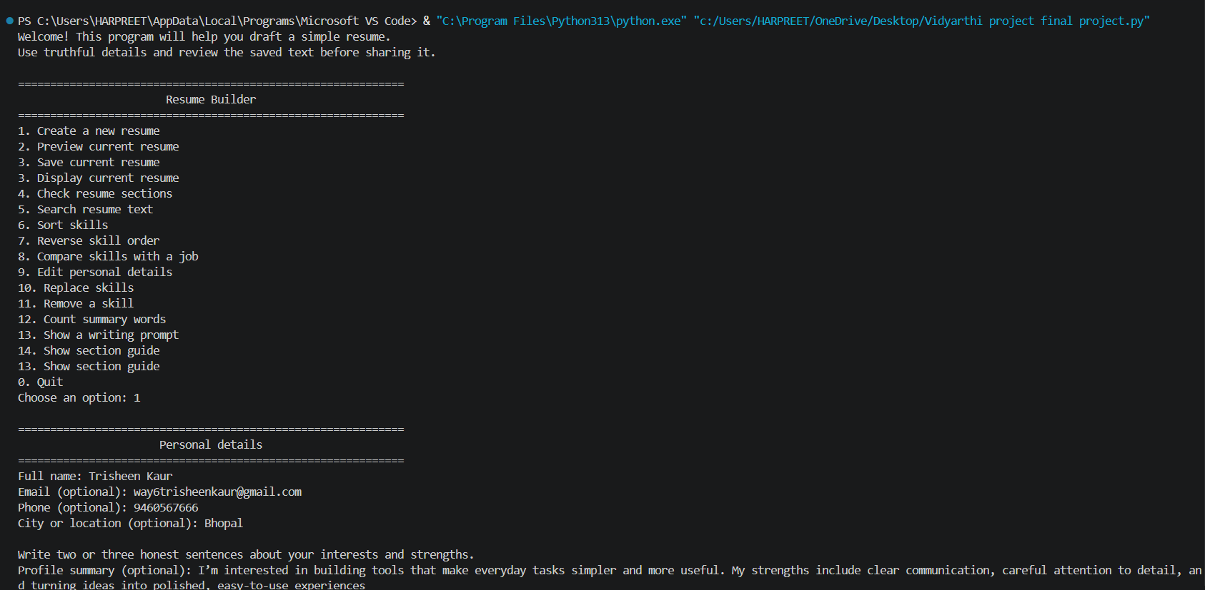
()
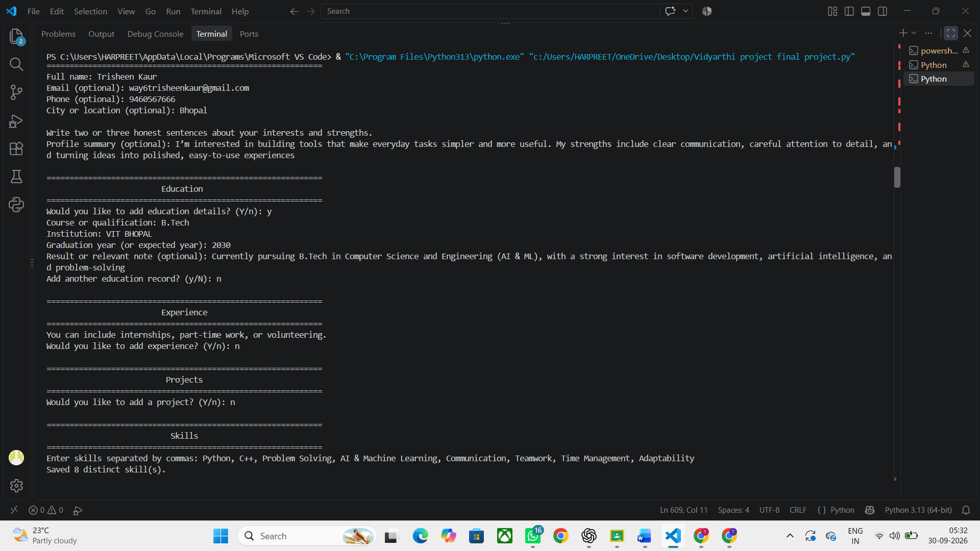
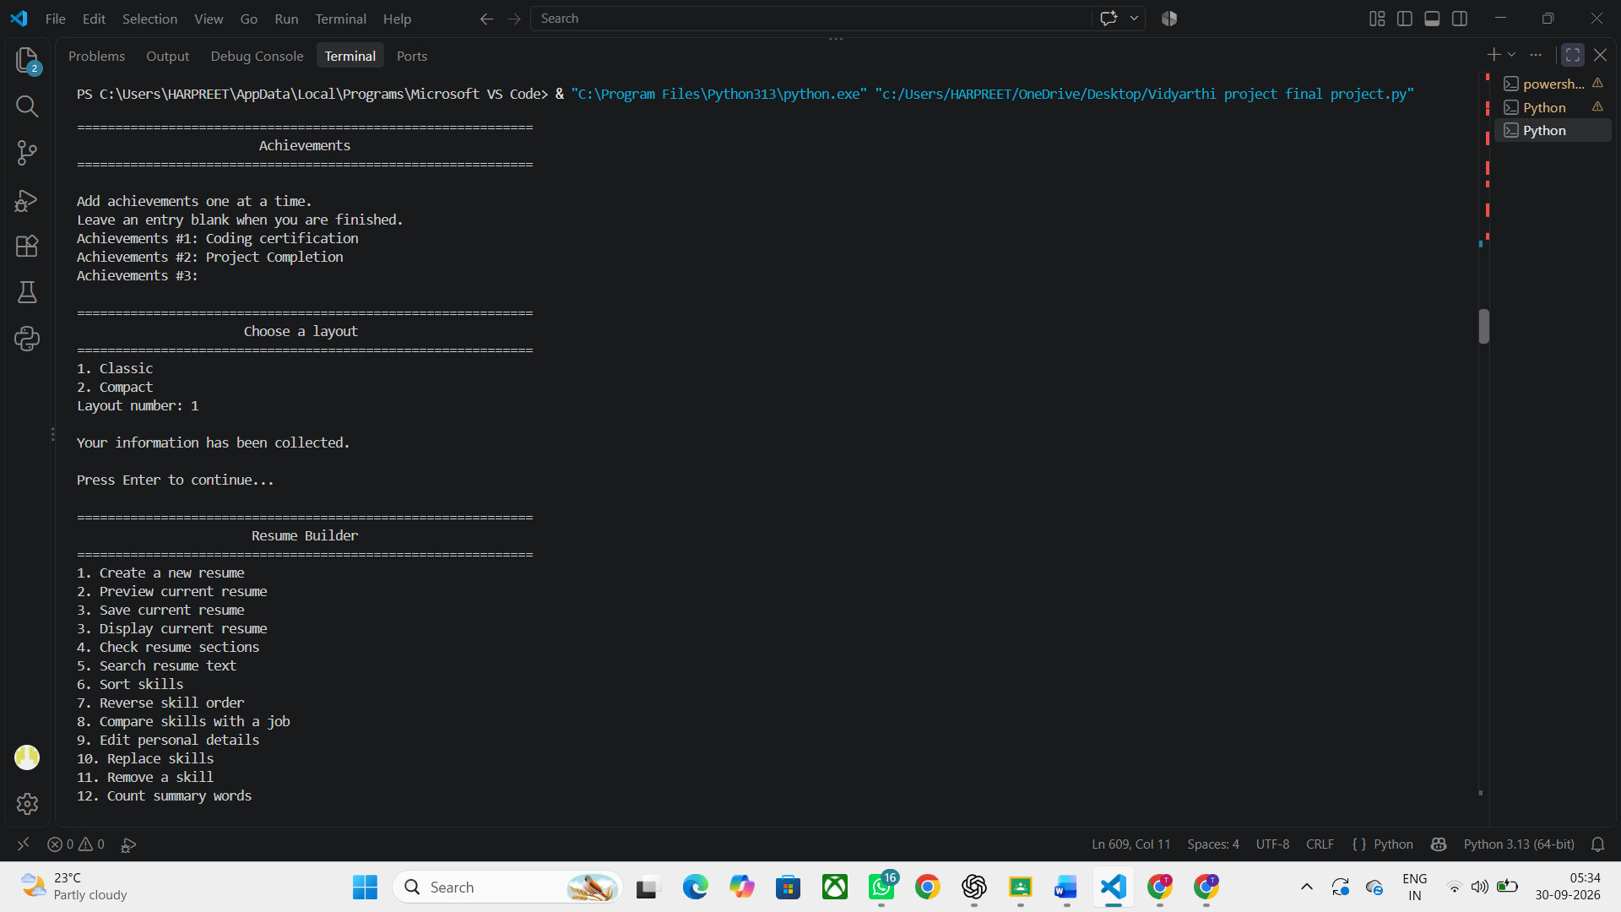
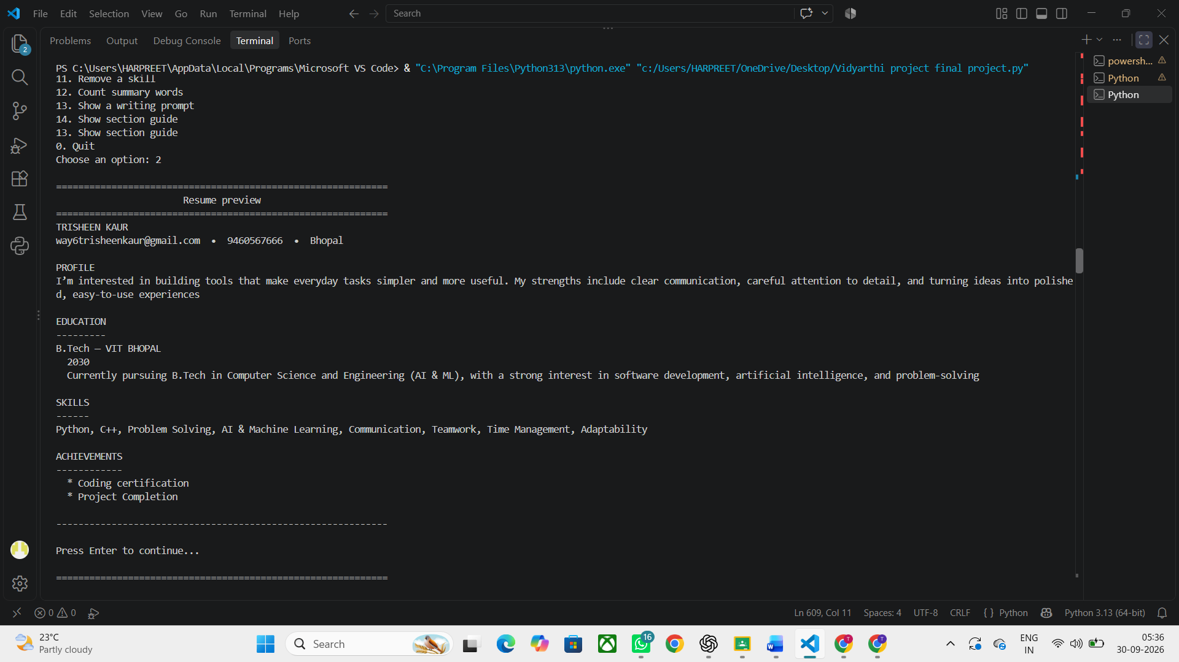
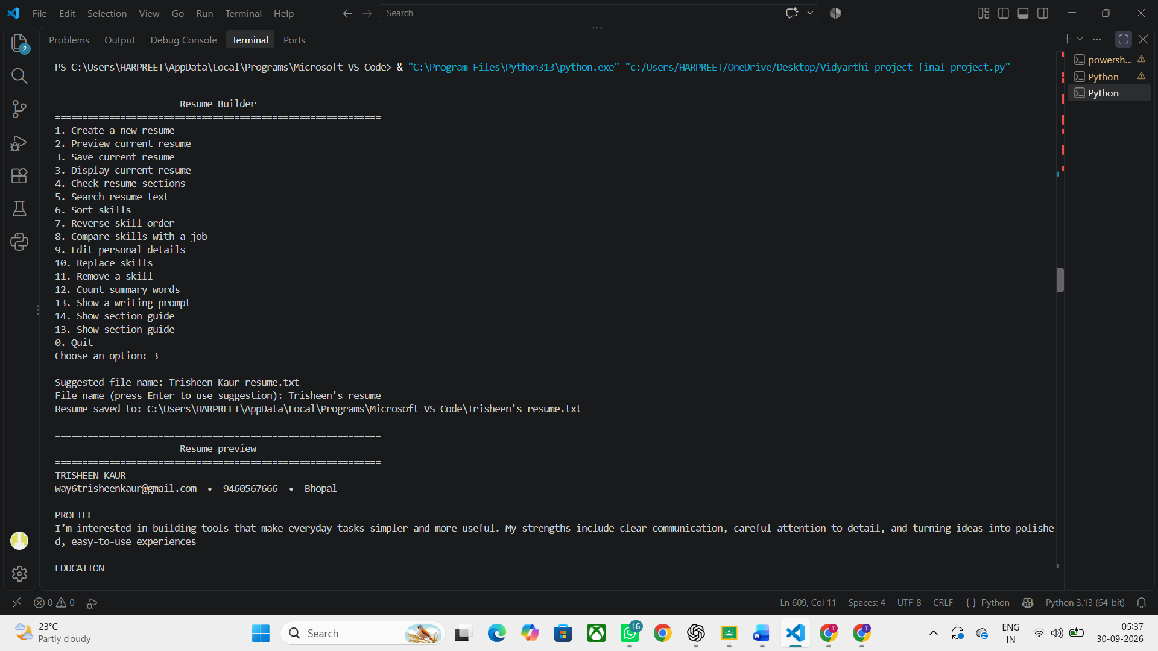
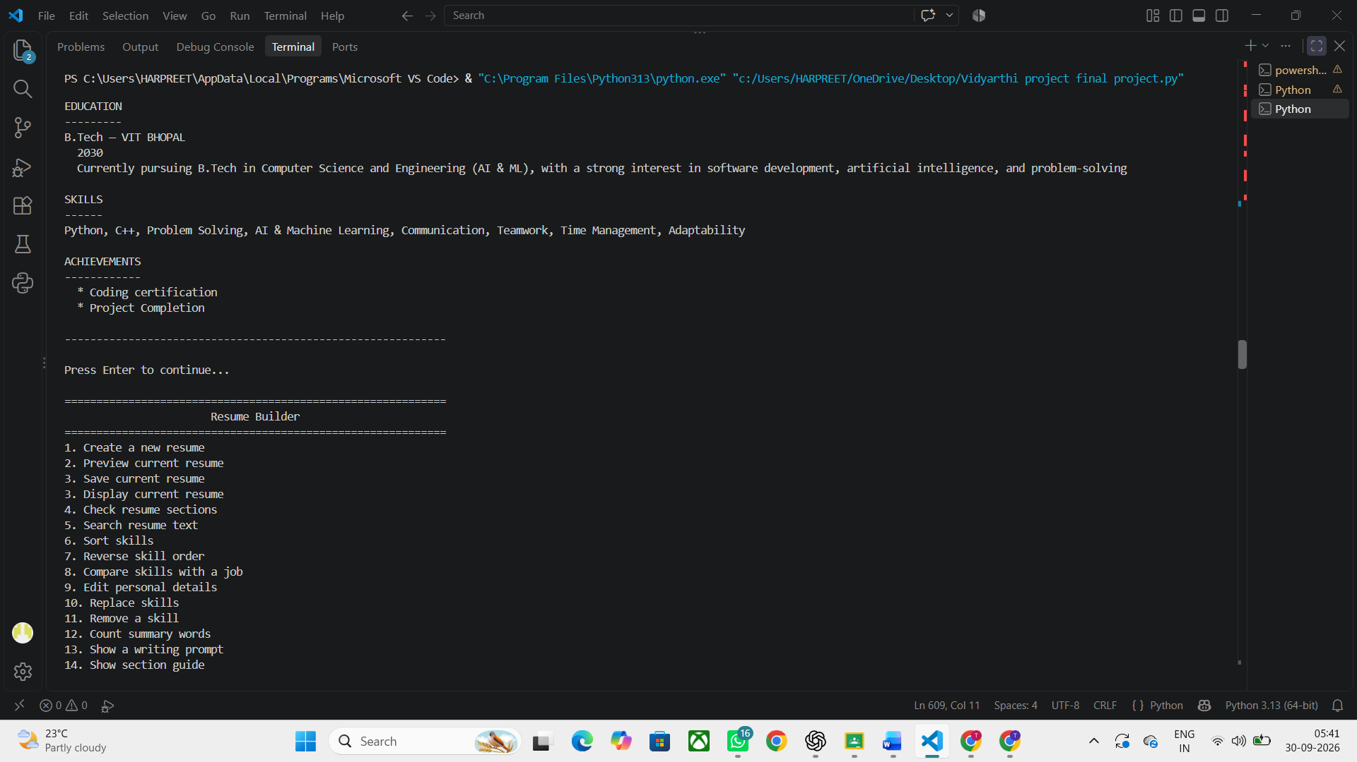
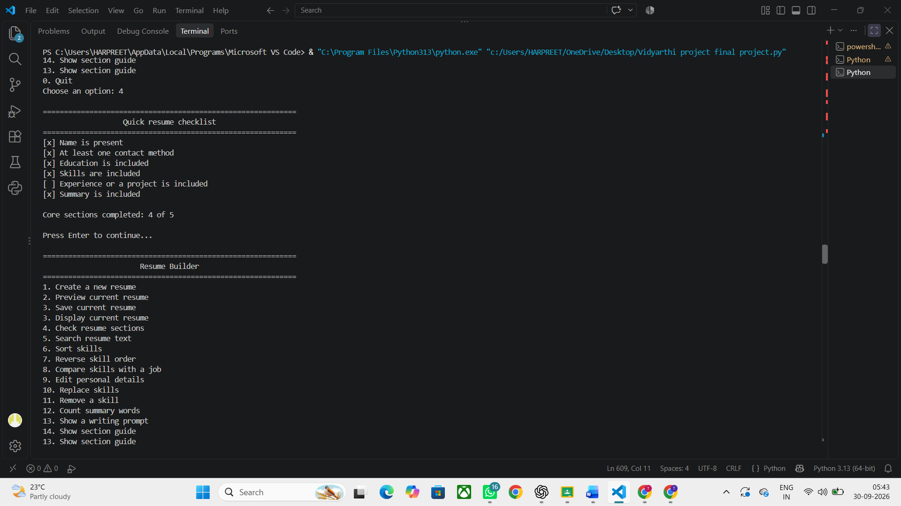
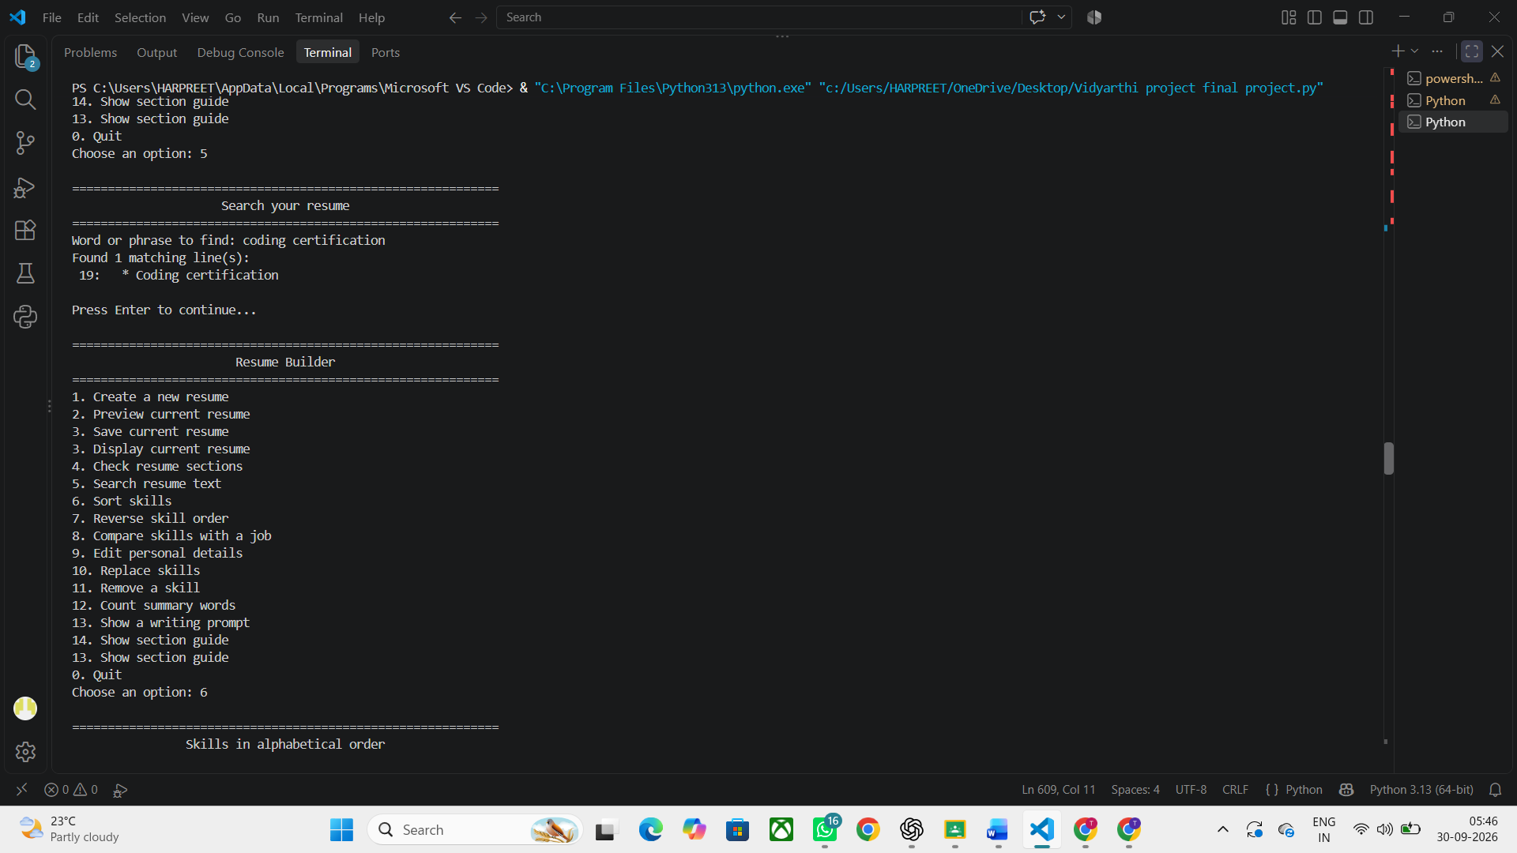
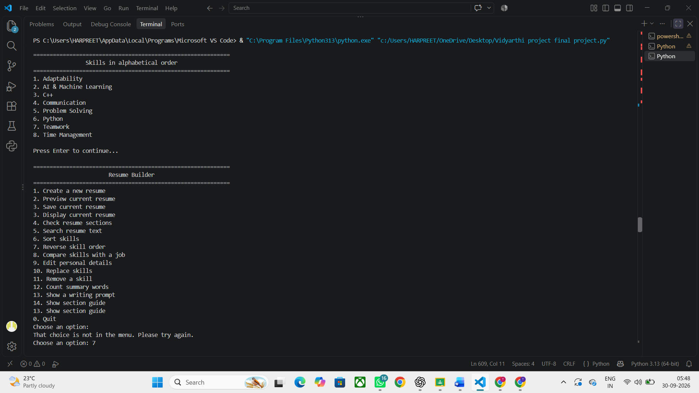
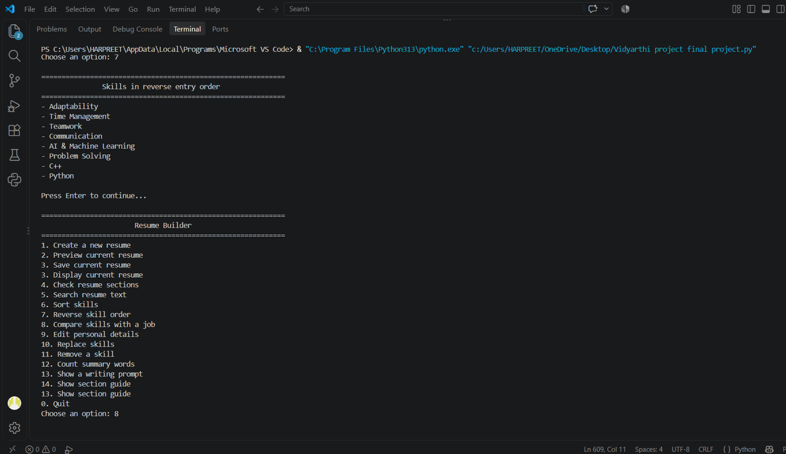
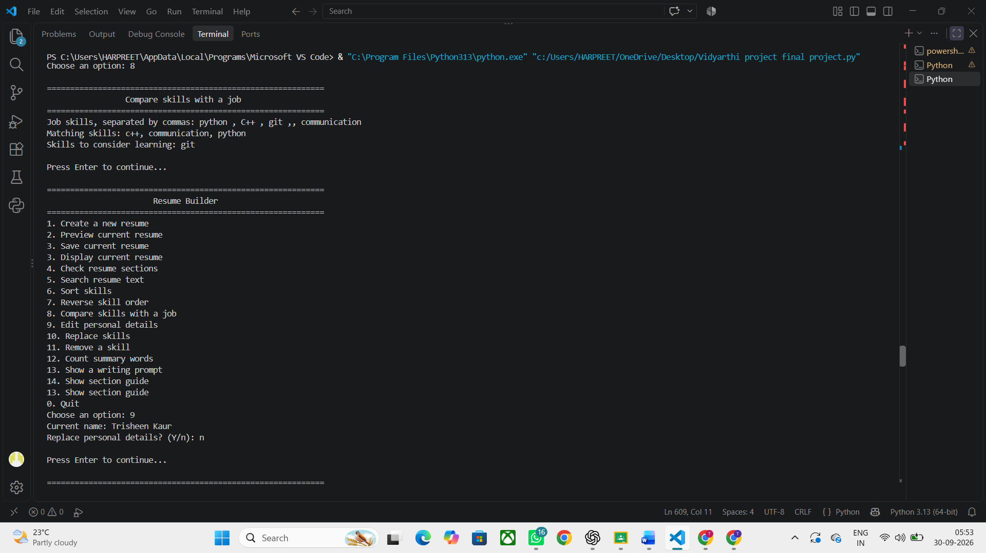
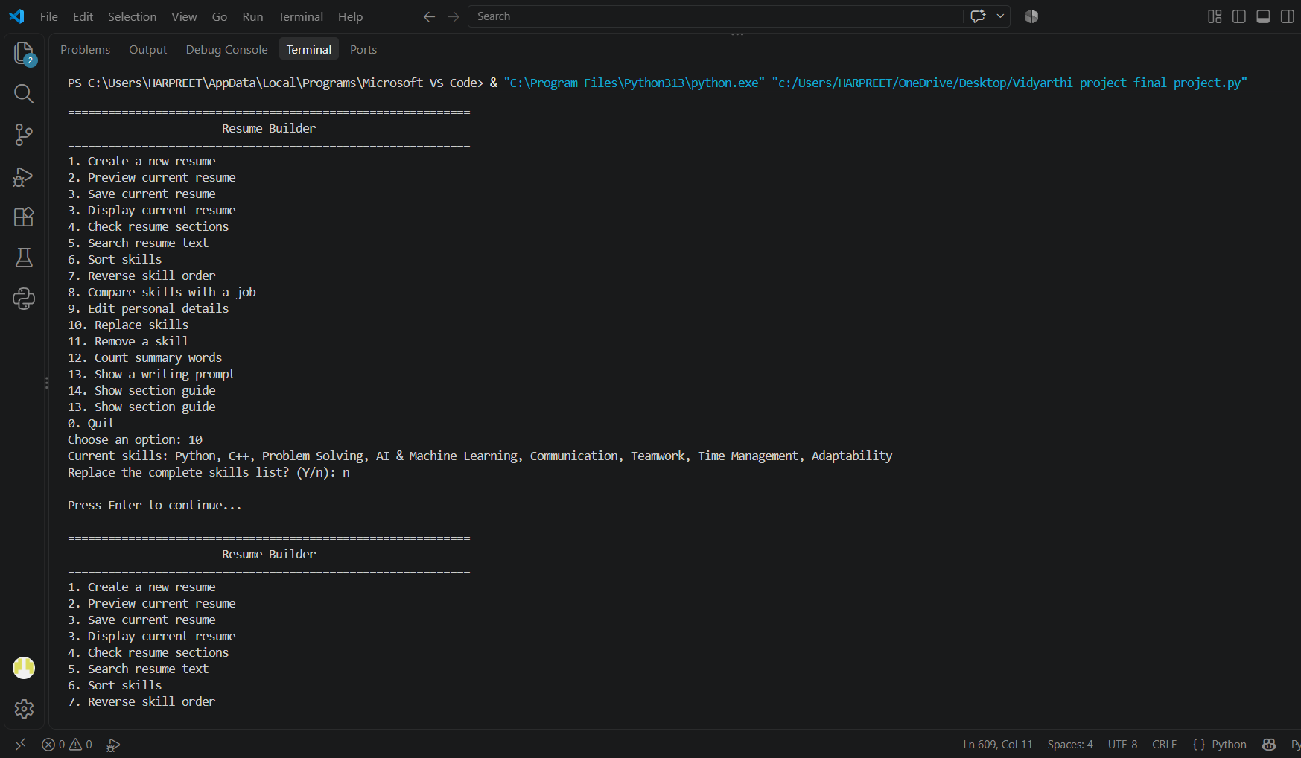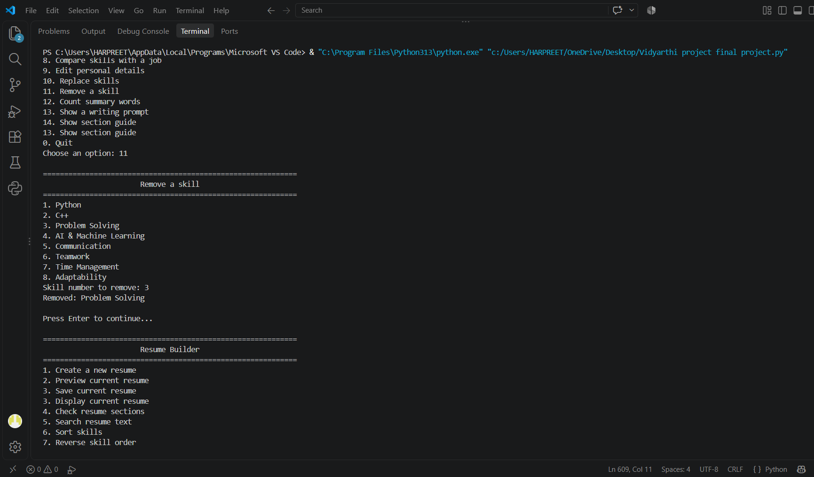
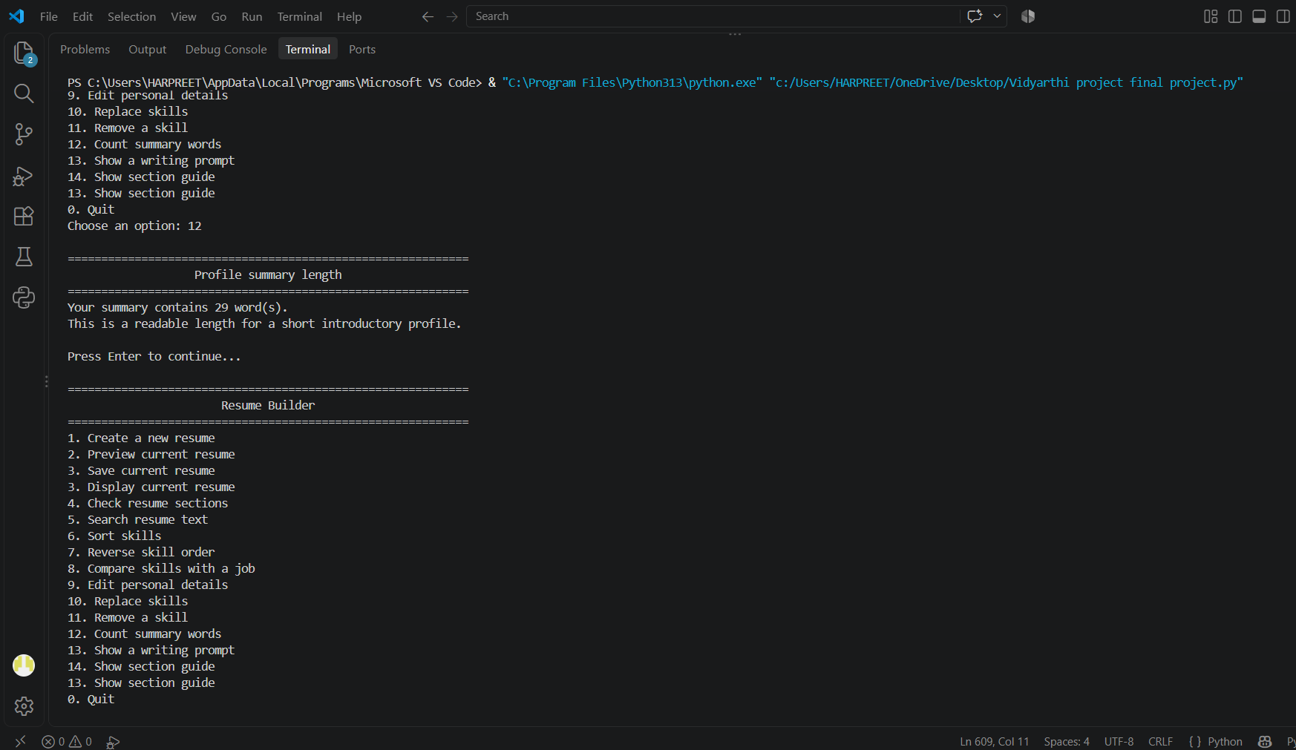
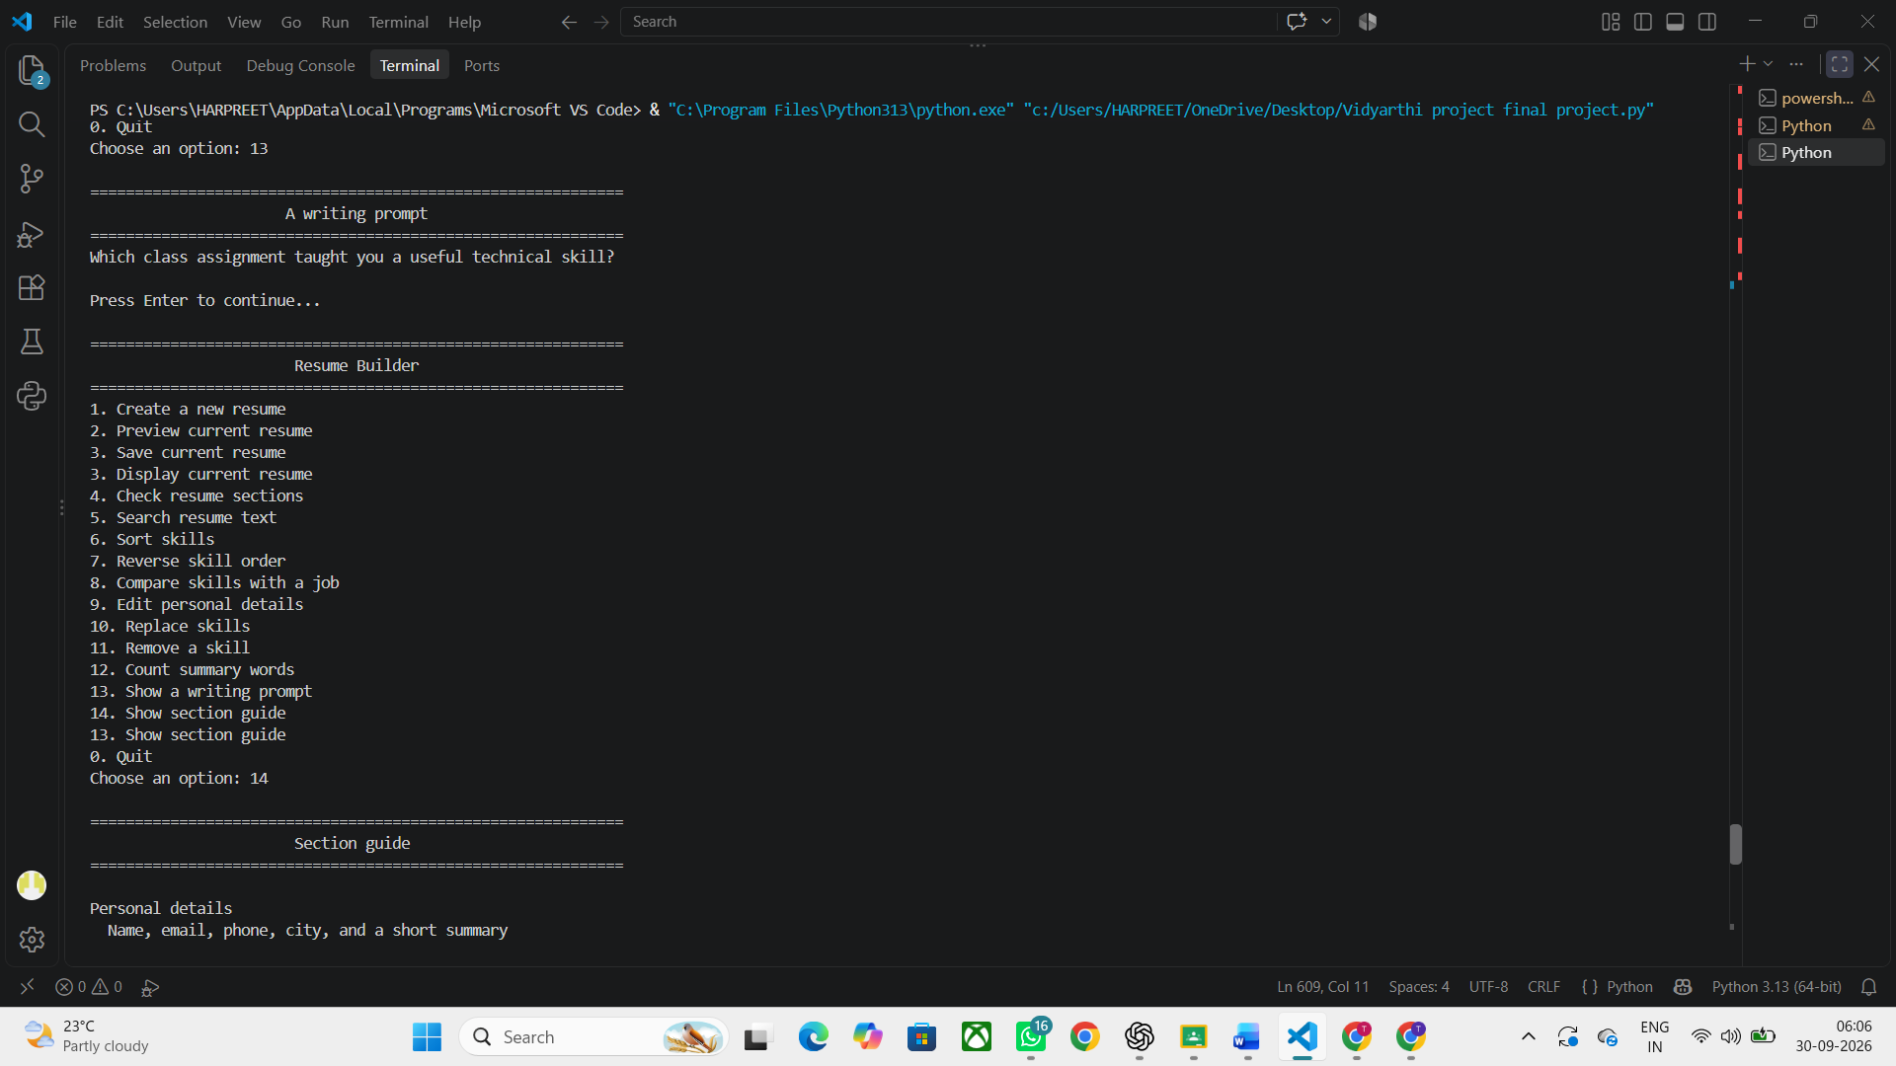
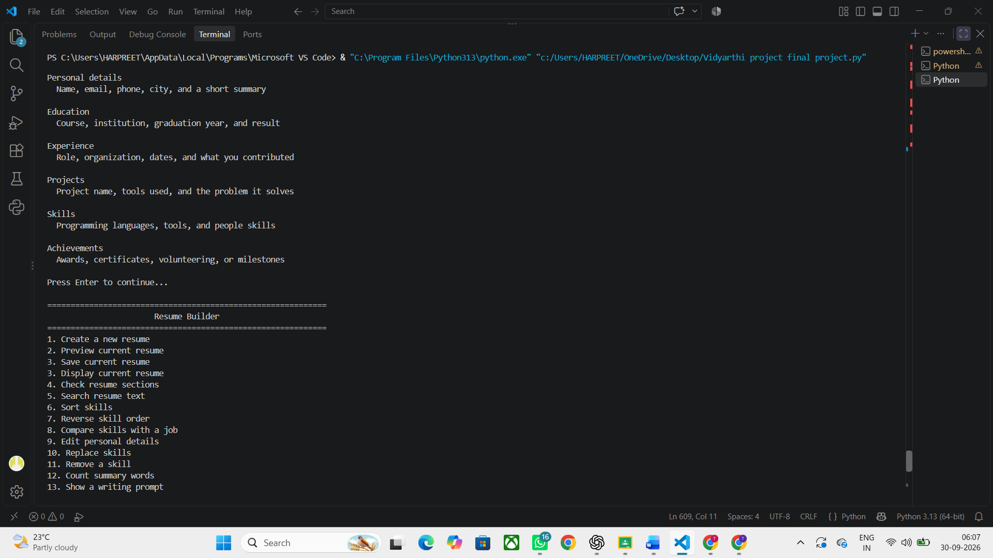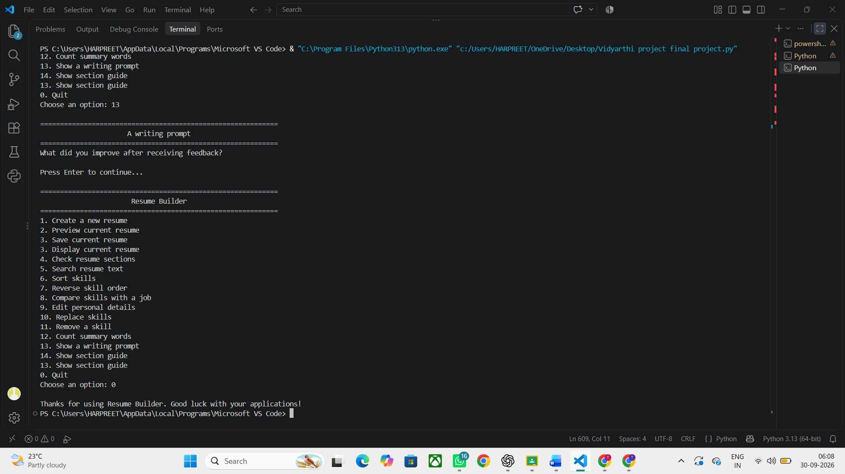
CONCLUSION

The Python resume builder project is a successful demonstration of how simple programming interfaces can be used together to create a practical and useful application. This project provides a simple methodology to create a structured resume by collecting information from the user and storing it in various sections. Instead of manually arranging each piece of information, this application performs this basic programming task of collecting, saving, formatting, and printing the information in a consistent way.
Through this project, multiple basic Python programming concepts are learned and applied to a real-life scenario. The use of variables is used to hold the information entered by the user, the use of the "input()" function is used so the user has the ability to interact with the program, the use of the "print()" function is used to output the final information, string formatting is used to present the information in a readable and organized format. Additional concepts such as functions, loops, conditional statements, lists, and data structures can be used to enhance the program.
One of the great benefits of developing this project is that it gives the user real-life experience with solving a novel problem with programming. Instead of theoretical applications of Python concepts, this project shows how these concepts work together in an application. Gathering user information and spitting it into a nicely formatted resume also improves one’s logical thinking and problem solving skills.
The project is designed for students and novices as creating a resume is an essential step for applying to internships, projects, college activities and jobs in the future. Creating and implementing a simple Automated Resume Builder can help cut down many hours of tedious and repetitive work in arranging basic information while also showing the students the importance of presenting their qualifications properly.
The project also gives an opportunity to do further work. The current program can be used to generate a resume with basic skeleton, but it may be developed to include more features. It may use file handling to save the resumes for later use, PDF generation for printing the resume. The program can also be improved by adding a graphical user interface, making it into an interactive application. Also, it can provide several templates to choose from depending on the requirements.
One more possible improvement is to implement input validation. The program could prompt whether the logistics such as e-mail, telephone and other such information has been entered in the proper format, which can avoid mistakes in the entry and enhance the fidelity of the obtained resume. The program could also offer editing functionality so that users may modify their information before generating the final resume.
In brief, Python Resume Builder is an appropriate low-level work for beginners because it forms a bridge between programming knowledge and real-world application. It demonstrates the importance of taking input, storing data, logically analyzing, formatting and producing output of software. Moreover, this work has also enlightened the student about how a program can be created which can interact with the user and produce actual output from input.
The advancement of this project presents a practical experiment to use Python and an application for creating more advanced projects in the near future. The original Resume Builder can be extended into a more complete resume generation system by dozens of features and several optimizations. Thus, this project can be viewed as a good application scenario of Python programming, as well as a good chance to further refine programming, logical thinking, and problem solving skills.

